PRESS RELEASE  
27 February 2018

**Arts Work of the Future   
Tate Exchange, Tate Modern  
6-11 March 2018**

**Get hands on with exploring the role of technology in the arts and join us in questioning and re-thinking its impact on our lives**

For one week from 6-11 March 2018 the Digital Maker Collective, University of the Arts London (UAL) and invited guest contributors/makers from across the globe will transform Tate Exchange, Tate Modern into a large public tech innovation studio.

A space to get hands-on with technology exploration and rapid prototyping, and discover new forms of collaborative digital making experimentation.

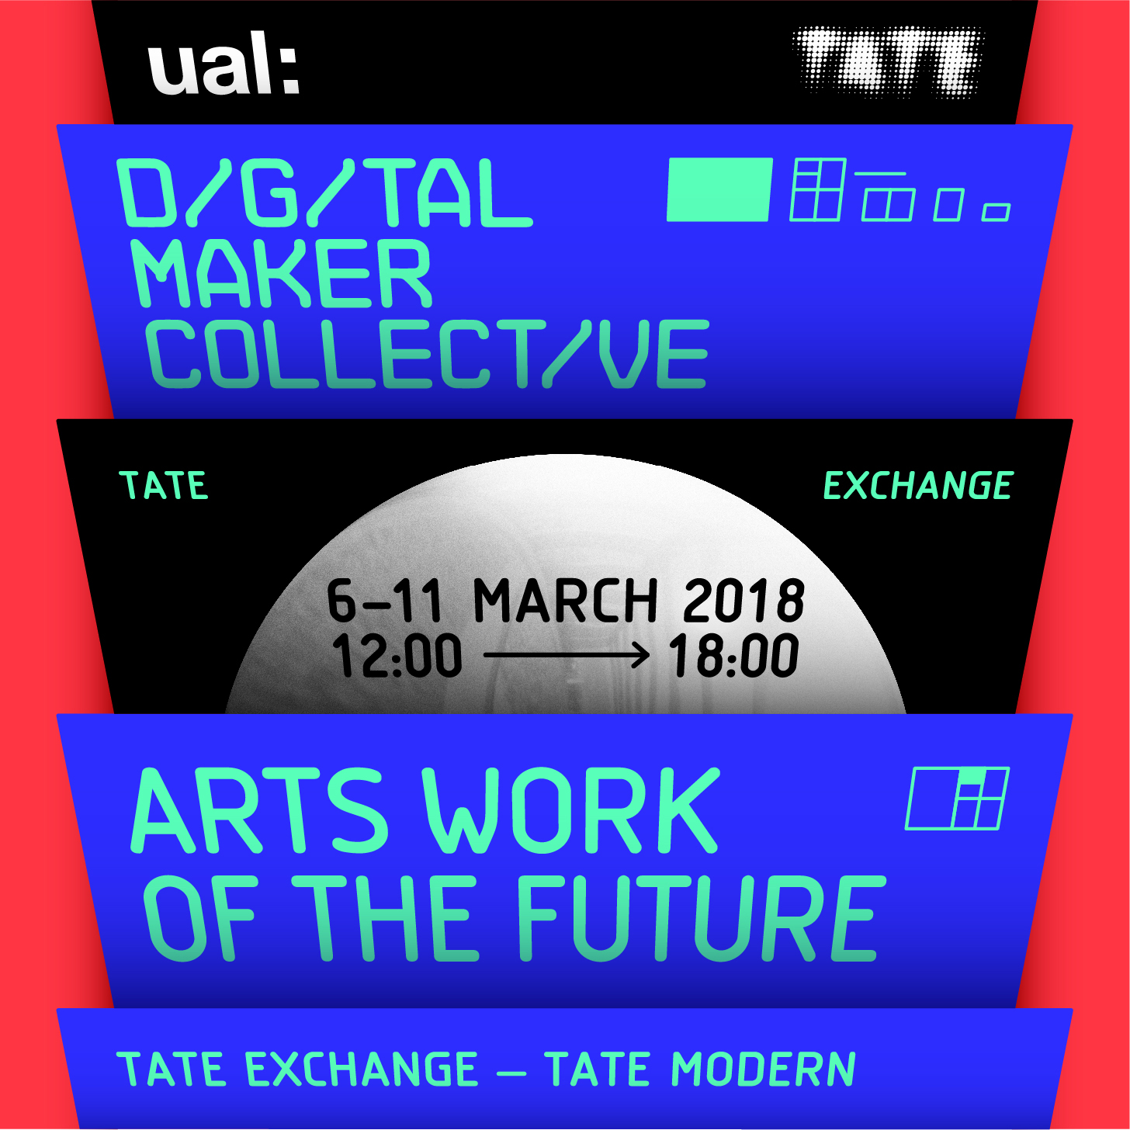

Help us reimagine the role of the arts in an age of rapid technological change and explore how, through the arts, we can move beyond everyday consumption and technology as a spectacle. Together let’s challenge the mainstream, say the unsaid and address inclusion, integration and the production of technology in our lives, society, work, education – and in the arts.

# ****Arts Work of the Future will include:****

* **Two open innovation tech incubators:** located on either side of the Tate Exchange. Each incubator includes an open studio, drop-in style working spaces, as well as a larger programmed space where tech workshops, experiments and debates will be showcased and performed throughout the week.
* **Incubator One: Are Humans Sustainable?**Explores the potential of the human species to survive and thrive within new technological environments
* **Incubator Two:** **What is the future of interaction?** Rethink virtual and physical space with interactive audio and visual projects.
* **Practice as Research Wall:**A place to map progress throughout the week.
* **Un-conference Space:** Will technology enslave us or save us? (public led debates).
* **Welcome Area & Bionic Art Student:**Help us build the Six Million Dollar Bionic Art Student of the future, ‘we have the technology’.

Throughout the week, you will have the opportunity to engage in digital making, co-creation and open innovation and question the positive and negative impacts of technology in our lives, and help make a difference to society.

# ****Incubator One:****

## Are Humans Sustainable?

This incubator explores the potential of the human species to survive and thrive within new technological environments

**It compasses four Digital Maker Collective led Provocations:**

* **Humans, Technology and Artificial Intelligence...** explores our changing relationship with technology.
* **Growing Space** - is a space for growing and is sourced locally from waste.
* **Is Technology Killing our creativity**? - questions whether artificial creativity is a help or a hindrance to human imagination.
* **Experiencing Sustainability issues** - explores micro-plastic pollution through interactive technology.

**Industry/Sector/Edu/Maker Guest Contributors:**

* **GreenLab** - We design sustainable food systems (London).
* **SPACE10** - A future Living Lab (Denmark).
* **EU Open Design Manufacturing Project** - (EU & China).
* **My Furniture Works MAID CSM -** Open Manufacturing for overcrowded living project (London).
* **South Devon College** - (Devon).
* **SenSat:** Commercial drones that make 3-D maps of your city for driverless car systems (London).

# ****Incubator Two:****

## What is the future of interaction?

This incubator will rethink virtual and physical space with interactive audio and visual projects

**The five Digital Maker Collective led ​provocations include:**

* **I’m lonely, what can I do**? - Question the mix of gaming in simulated environments and real time by using virtual reality and constructing a puzzle.
* (***human ± technology) let's update together-***  code and activate light installations and experience unseen interactions between the physical and virtual.
* **Movement & Technology** - generate sounds through your body movements. Get ready to experience physicality of sound in a new way!
* **Dance practice from physical to virtual space** - movement, balance, scale, and gravity.
* **The Assembly Line** - exploring international collaboration through Virtual Reality (Parque Explora, Colombia).
* **Vapor Tate** – explore an alternate Tate Exchange experience in Virtual Reality.

**Industry/Sector/Edu/Maker Guest Contributors:**

* **Lodz University of Technology, Fablab Lodz** - How people want a robot to represent them? (Poland).
* **Cyland Media Art Lab** - Community of artists, critics, curators, coders, engineers and media activists from (Saint Petersburg, RU).
* **South London Raspberry Jam** - Giving young people the opportunity to explore coding, physical computing and digital making in a fully inclusive environment (London).
* **Future Makers Collective** - Institute of Technology, Tallaght, Dublin. Researching societal structures and technologies which control our world. (Ireland).

# ****Un-conference Space:****

## Will technology enslave us or save us?

In parallel, but away from the busy main floor, come and join the ‘will technology enslave us or save us?' un-conference.

Throughout the week, we will host a space for open public debate & conversations? Open to anyone, just sign up, propose a technology related topic, ask questions on the day and then discuss with others in a relaxed and informal setting.

This is a space to stop, pause and reflect, so we can try and make sense of our digital utopian and dystopian futures.

# ****Practice as Research Wall:****

## Mapping Our Progress

Throughout the week we will be mapping our progress, a space for pulling together all the findings throughout the week and building collaborations (new collaborative projects, funding bids, exhibitions, exchanges, conferences, publications etc.) we can take forward after the residency.

# ****Welcome Area:****

## Six Million Dollar Bionic Art Student ‘we have the technology’

Welcome Area - Visitors are welcomed into the event by hologram talking student robot, providing an overview of what is happening on the floor.

Alongside the relaxed welcome area, you are invited to get hands on by helping us imagine and build a **Bionic Art Student,** better, stronger, faster than before, we have the technology.

The Bionic Art Student aims to provoke debate about the 'Arts Work of the Future' - what is the role of creativity in the work of the future?

* How are technologies changing future creative attributes?
* Can technology make art education more accessible?
* Are creatives leading the digital revolution/industry or being led by digital revolution/industry?
* How is technology changing creativity, creative learning and work?
* How far can creativity be automated?

For more Information and details of the week-long programme please visit: <http://digitalmakercollective.org> and the ***#****artsworkofthefuture* hashtag.

This event is programmed by [Digital Maker Collective](http://digitalmakercollective.org/), a Tate Exchange Associate.

**About the Digital Maker Collective**

The [Digital Maker Collective](http://digitalmakercollective.org/) are a group of artists, designers, staff and students from the University of the Arts London (UAL) who explore emerging digital technologies in arts, education, society and the creative industries. They are supported by Camberwell, Chelsea and Wimbledon Colleges of Arts (CCW), UAL.