**Digital Making Art School   
Tate Exchange 8th Feb 2017**

**Collective Base Camp**

Help us create new work and ideas to take forward together

**Virtual Reality:**

* VR Explorers – 13:00 - 16:00  
  Work alongside students as they explore VR in both spatial design and fine art practices
* Virtual Meets Reality – 12:00 - 13:00 & 16:00 - 17.15  
  An opportunity to experience Virtual Reality and express your creativity

**Physical Computing:**

* Machine-Mind (Physical Computing) – 12:00 - 16:00  
  Walk through the mind of a robot, and explore the subjectivity of perception.
* Soft Circuits in the Switch House – 12:00 - 16:00  
  Play with paper circuits and a sound map of the Tate Modern

**Bio Feedback:**

* Learn about Raspberry Pi, Arduino & EEG headsets - 14:00 - 17:00
* Activating Sonic Sensing through Bones & the Building 12:00 - 16:30

**Robotics:**

* JaXon - Bad Robot: 12:00 - 17:15   
  Arduino powered dancing robot, controlled via a keyboard
* Robot Hacking with the Crumble: 14:30 - 17:30  
  Led by 11-Year-Old, Femi.Build robots using takeaway containers & ultrasonic sensors

**Debate:**

* Tate Exchange Series of Informal Discussions, Talks and Crits: 13:00-17:30

**Tech Pit Stop:**

* A space for general work in progress and experimentation, please pop-in for a chat.

**Open Workshops:**

* A participant driven workshop space which will allow any member of the Collective to propose & deliver workshops on the day

**Tech Cluster**

Virtual Reality Symposia: Virtual Histories 12:00-14:30

So what is being done with Virtual Reality, what are the implications and potentials for Art and Design?

**Wonder Wall**

Student-led Crit – 12:00 – 17:30

Exchange your ideas in relaxed, intimate and informal discussion. Roundtable, Walking, Crit on the Wall

Online listening platforms – 12:00 – 17.30

Challenge and explore listening experiences through a series of regular discussions, live performances

**Projects Space**

Gesamt - 12:00 – 17:30Total operatic collaboration of the digital and the actual

‘Ubernism’ Part 1 – 12:00 – 17:00

A Camberwell & Chelsea College of arts collaboration

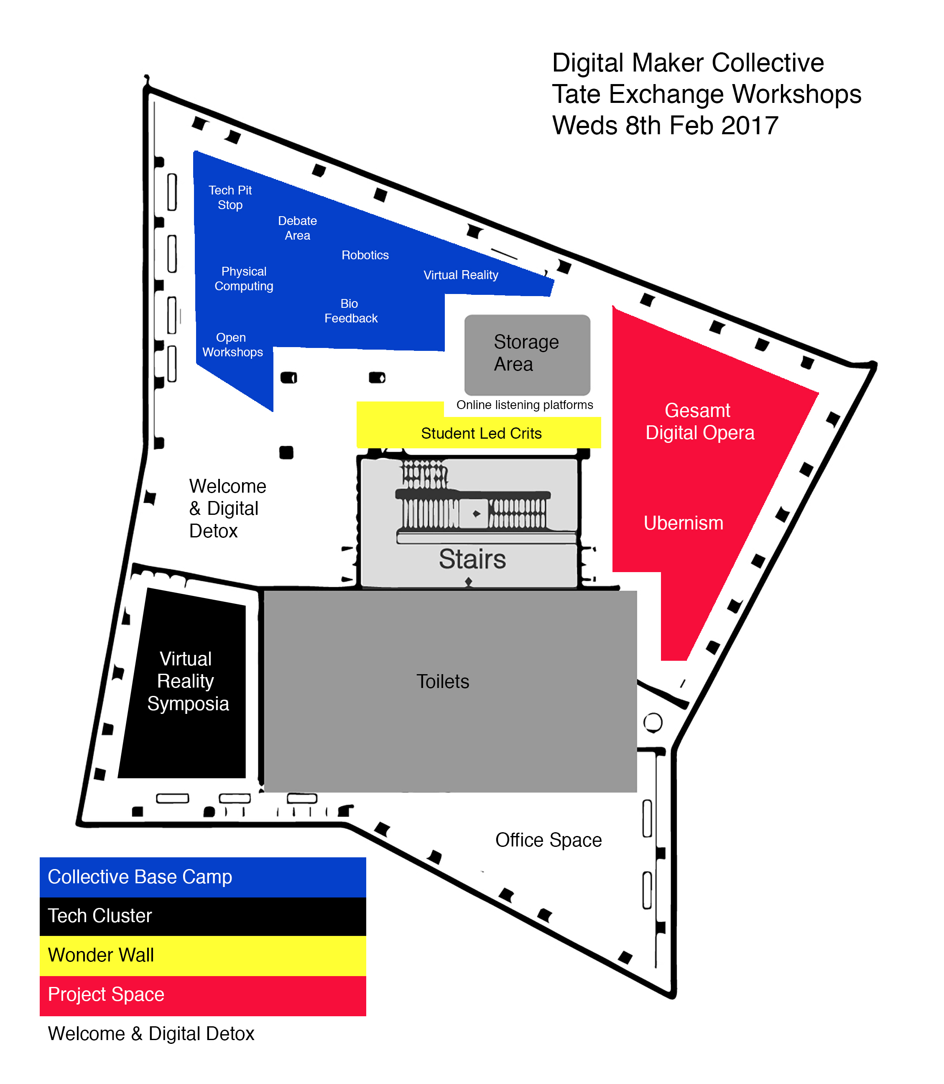

This event is programmed by Digital Maker Collective, a Tate Exchange Associate.

### About the Digital Maker Collective

The Digital Maker Collective are a group of artists, designers, staff and students from the University of the Arts London (UAL) who explore emerging digital technologies in arts, education, society and the creative industries.

They are supported by Digital Learning, Teaching & Enhancement at Camberwell, Chelsea and Wimbledon Colleges of Arts, UAL.

http://digitalmakercollective.org   
@tateexchange @CCWDigital #artsDMC #tateJAM